**Global Airplane Crashes (1918 - 2022): Root Cause Analysis**

Team Information 3

Introduction 4

Story of Data 6

Data Splitting and Preprocessing 8

Pre-Analysis 10

In-Analysis 12

Post-Analysis and Insights 18

Data Visualisations & Charts 20

Recommendations and Observations 28

Conclusion 33

References 35

# **Team Information**

Purpose  
This report analyses global airplane crash data from 1918 to 2022 to identify root causes, trends, and opportunities for enhancing aviation safety protocols. It aims to provide actionable insights for stakeholders to reduce crash incidents and improve safety standards.

Sections  
The report covers an introduction, data story, preprocessing, analysis phases, visualisations, recommendations, limitations, and a conclusion with future research directions. Each section focuses on specific aspects of crash analysis to ensure a comprehensive understanding.

## Assigned Team

We, as members of Team 6, collaborated on this project to conduct a thorough root cause analysis of global airplane crashes. Our collective efforts focused on delivering a comprehensive report to enhance aviation safety.

## Team Objectives

Our team aimed to deliver actionable insights from the dataset spanning 1918 to 2022, focusing on crash causes, regional patterns, and safety improvements. Our expertise in simulation and data analysis as Team 6 enabled us to thoroughly evaluate aviation safety trends, with the goal of providing recommendations to enhance aviation safety protocols worldwide.

# Introduction

## Objective of Project

The objective is to examine global airplane crash data from 1918 to 2022, focusing on identifying primary crash causes, regional patterns, flight phases, and aircraft types. The goal is to propose strategies for improving aviation safety and reducing crash incidents worldwide.

## Problem Being Addressed

Air travel is a critical global industry, and each airplane crash has severe consequences, including loss of life, economic impact, and reduced public confidence in aviation safety. This analysis seeks to pinpoint leading crash causes, identify high-risk regions and flight phases, and provide actionable insights to minimise fatalities.

## Key Datasets and Methodologies

The dataset includes historical crash records from 1918 to 2022, covering crash counts, fatalities, regions, aircraft types, flight phases, and causes. Microsoft Excel was used, leveraging Pivot Tables for data aggregation and chart creation, and we also provided visualisations using Power BI to enhance our analysis with interactive dashboards.

## Overview of Safety Performance Dashboard

The Global Airplane Crash Dashboard 2022 consolidates key metrics, such as total crashes (28.53K), total fatalities (157K), and regional distributions. It serves as a comprehensive tool to identify safety challenges and guide improvements based on historical data analysis, with Power BI adding interactive elements to our visualisation approach.

# Story of Data

## Data Source

The dataset is sourced from a [global aviation incident database](https://www.baaa-acro.com/index.php/crash-archives) and [Kaggle](https://www.kaggle.com/datasets/abeperez/historical-plane-crash-data) capturing detailed records of airplane crashes from 1918 to 2022. It was compiled for analytical and safety research purposes to support aviation safety improvements.

## Data Collection Process

Data was gathered from aviation authority reports, airline incident logs, and crash investigation records. Manual categorisation by region, aircraft type, flight phase, and crash cause ensured comprehensive coverage of historical incidents.

## Data Structure

The dataset is structured in a spreadsheet format, with each row representing an individual crash. Columns include descriptive attributes (e.g., date, aircraft, operator, crash cause) and outcome metrics (e.g., survivors, fatalities, crew on board).

## Important Features and Their Significance

Key features include crash cause, which identifies primary reasons for incidents, and region/country, which highlights geographical patterns. Flight phase pinpoints high-risk stages, aircraft type reveals model-specific risks, and fatality/survivor metrics assess crash severity and safety outcomes.

## Data Limitations or Biases

Some records may have missing or inconsistent values, especially for causes or circumstances. The dataset may also lack recent data updates or technical variables like aircraft age or maintenance history, which could limit the depth of insights. Additionally, regional reporting variations and subjective crash cause categorisation could introduce inconsistencies in the analysis.

# Data Splitting and Preprocessing

## Data Cleaning

Duplicates were removed using Excel’s “Remove Duplicates” tool to ensure data accuracy. Inconsistencies in fatality counts or crash causes were resolved by cross-referencing with aviation authority reports for reliability.

## Handling Missing Values

Missing data for survivors, crash causes, or circumstances were imputed using averages from similar regions, flight phases, or aircraft types. This approach ensured analytical continuity despite gaps in historical records.

## Data Transformations

Calculated metrics, such as survivor-to-fatality ratios (survivor rate = survivors / fatalities * 100) and crash rates by flight phase, were added to facilitate trend analysis. No advanced statistical modelling was needed, as Excel tools were sufficient.

**Independent Variables**

The independent variables in the dataset include date, aircraft type, operator, flight phase, flight type, crash site, schedule, crash location, country, region, circumstances, crash cause, month name, year, and day. These variables represent the factors that may influence crash outcomes and were used to segment the data for analysis.

**Dependent Variables**

The dependent variables consist of survivors, crew on board, crew fatalities, passengers on board (PAX on board), passenger fatalities (PAX fatalities), other fatalities, and total fatalities. performance.

## Industry Context

The dataset pertains to the aviation and safety industry, where understanding crash causes and regional risks is vital. This is especially critical in a rapidly growing global air travel sector focused on improving safety protocols.

Stakeholders  
Key stakeholders include aviation authorities, airlines, safety regulators, insurance firms, and policymakers, all focused on reducing crash rates and enhancing passenger safety through data-driven insights. Additionally, Vephla University mentors, as well as researchers and data analysts interested in transportation safety, would benefit from the findings to advance academic research and safety studies in the aviation sector.

## Value To the Industry

Insights from this analysis can improve pilot training, refine aircraft design, and strengthen regulatory frameworks. For Vephla University mentors, researchers, and data analysts, the findings provide a foundation for further transportation safety studies, contributing to academic and practical advancements in aviation safety. Ultimately, it contributes to safer air travel by addressing root causes and high-risk areas in aviation operations.

# Pre-Analysis

## Key Trends

1. **Regional Crash Counts**

The USA accounts for the highest number of crashes (6,601), followed by the UK (2,388) and Russia (1,503). This suggests regional operational or environmental risks that require targeted safety interventions.

2. **Seasonal Patterns**

Seasonal peaks in certain months, such as summer months showing higher crash frequencies, indicate potential weather or traffic-related influences. These patterns highlight the need for seasonal safety measures.

3. **High-Risk Flight Phases**

Most crashes occur during take-off and landing phases, with historical data pointing to human error and weather as key factors. This underscores the importance of phase-specific training and monitoring.

## Potential Correlations

1. **Landing/Descent and Human Error**

High crash rates during landing/descent may correlate with human error or adverse weather conditions. This suggests a need for improved pilot training and weather forecasting tools.

2. **Older Aircraft and Crash Frequency**

Older aircraft models, like the Boeing 737-200, have a higher crash frequency, suggesting a link to ageing fleets. This indicates the need for fleet modernisation or retirement strategies.

3. **Aircraft Design and Survivability**

The Douglas C-47’s high survivor count (2,171) may indicate robust design, potentially correlating with better crash survivability. This highlights the role of aircraft design in safety outcomes.

## Initial Insights

1. **Dominant Crash Causes**

Human error and weather are leading causes, with human factors dominating particularly in North America (3,919 cases). This highlights the need for improved training and forecasting to address these risks.

2. **Regional Disparities**

Certain regions, such as the USA (6,601 crashes) and UK (2,388), have significantly higher crash rates, suggesting localised safety challenges possibly due to high air traffic or ageing fleets. Targeted interventions in these regions are essential.

3. **Seasonal Risks**

Crashes happen more during certain months or days, with summer months showing higher crash frequencies, raising questions about operational and environmental factors during high-traffic periods. Pre-season safety measures could mitigate these risks effectively.

# In-Analysis

## Unconfirmed Insights

1. **High-Risk Flight Phases**

The flight phase accounts for the highest number of fatalities (66,984), followed by landing/descent (36,343) and take-off/climb (34,634). These phases are driven by high workload and environmental factors, underscoring the need for focused safety measures.

2. **Dominant Crash Causes**

Human factor crashes are dominant, particularly in North America (3,919), Europe (2,002), and Asia, with technical failures also significant, especially in North America (4,718) and Europe (1,374). This highlights the interplay of human, technical, and environmental factors in crashes.

3. **Aircraft-Specific Risks**

The Douglas C-47 Skytrain (DC-3) has the highest number of passenger fatalities (2,382) and crew fatalities (4,743), totaling over 12,000, while the Boeing 737-200 is among the top in both fatalities (3,004 passengers + 247 crew) and crash counts. In contrast, the Douglas C-47 recorded the highest number of survivors (2,171), and the PZL-MIELEC AN-2 had the highest survival rate when measured by the ratio of survivors to fatalities.

4. **Temporal Trends**

Fatal crashes have decreased over the decades, reflecting technological and regulatory advancements. However, regional patterns in the USA (6,601 crashes) and UK (2,388 crashes) suggest dense air traffic or operational challenges.

5. **Crew vs. Passenger Survivability**

Crew survival rate is often lower than passenger rates, likely due to proximity to impact zones. This indicates a need for improved crew safety measures and crash-resistant cockpit designs.

6. **Flight Type Risks**

Scheduled revenue flights had the most crashes (6,034), compared to military (4,647) and training flights (3,300). Private flights may have lower safety compliance, pointing to the need for stricter regulations.

7. **Seasonal Crash Patterns**

Summer months show higher crash frequencies, possibly related to increased travel or adverse weather. Pre-season safety drills could help mitigate these seasonal risks.

8. **Operator Performance**

Some operators have recurring incidents, indicating potential weaknesses in training or maintenance. Operator-specific safety audits are needed to address these disparities and improve safety compliance.

9. **Fatality Rates by Flight Type**

Fatality rates are higher in unscheduled flights, further emphasising the need for enhanced safety standards in non-commercial aviation operations.

## Technical vs. Human vs. Environmental Causes

1. **Technical Causes**

Technical failures are a leading cause of crashes, particularly in North America (4,718) and Europe (1,374), stemming from mechanical issues or structural failures. These are often associated with older aircraft like the Boeing 737-200 and Douglas C-47, suggesting a need for enhanced maintenance and modernisation.

2. **Human Causes**

Human factors are the most prevalent, with 3,919 cases in North America, 2,002 in Europe, and significant instances in Asia, driven by pilot error, poor decision-making, or crew fatigue. This emphasises the critical role of human factors in safety outcomes and the need for improved training.

3. **Environmental Causes**

Weather-related risks are notable, with 515 cases in North America and 429 in Europe, indicating the significant influence of adverse climatic conditions on crash incidents, requiring better forecasting tools.

**Summary Information**

1. Cause Type: Technical, North America: 4,718, Europe: 1,374, Global Estimate: ~6,092
2. Cause Type: Human, North America: 3,919, Europe: 2,002, Global Estimate: ~6,000
3. Cause Type: Environmental, North America: 515, Europe: 429, Global Estimate: ~944

**Recommendations**

1. Enhancing pilot training for take-off and landing phases can mitigate risks associated with high workload, critical given the high crash rates in these phases (34,634 and 36,343 crashes).
2. Improving weather forecasting and decision-making tools can address the 515 weather-related crashes in North America. Real-time weather data integration into cockpits will enhance pilot preparedness.
3. Prioritising the modernisation or retirement of high-risk aircraft like the Boeing 737-200 and Douglas C-47 addresses their significant fatality tolls (3,004 passengers + 247 crew and over 12,000 total, respectively). This will reduce risks associated with ageing fleets.
4. Conducting safety audits in high-risk regions like the USA (6,601 crashes), UK (2,388), and Russia (1,503) can tackle elevated crash counts. Localised interventions will address specific operational challenges.
5. Implementing stricter regulations for unscheduled flights, especially military operations (4,647 crashes), aims to reduce incidents. Enhanced safety compliance in non-commercial aviation is essential.

## Analysis Techniques Used in Excel

**Pivot Tables**

Pivot Tables were used to aggregate data by region, aircraft type, flight phase, and crash cause. The outputs were used to generate charts for visualising trends and patterns effectively, complemented by our visualisations using Power BI.

**Pivot Table Procedures**

1. **Crash By Region**

A Pivot Table was created by dragging “Region” to Rows and “Total Crashes” to Values (Sum). A bar chart was generated to display top regions like the USA and UK.

1. **Fatalities By Aircraft Type**

“Aircraft Type” was dragged to Rows and “Total Fatalities” to Values (Sum). A pie chart was produced to show the Boeing 737-200 and Douglas C-47’s high fatality counts.

1. **Crashes By Flight Phase**

“Flight Phase” was dragged to Rows and “Crash Count” to Values (Sum). A pie chart highlighted cruising, landing/descent, and take-off/climb as high-risk phases.

1. **Crashes By Month**

“Month” was dragged to Rows and “Total Crashes” to Values (Sum). A line chart showed seasonal peaks, particularly in summer months.

1. **Crash Cause by Region**

“Region” was dragged to Rows, “Crash Cause” to Columns, and “Total Crashes” to Values (Sum). A bar chart illustrated human error, technical failures, and weather-related incidents by region.

# Post-Analysis and Insights

## Key Findings

1. The USA leads with 6,601 crashes, followed by the UK (2,388) and Russia (1,503). This reflects high air traffic and operational complexities in these regions, necessitating focused safety interventions.
2. Human error (3,919 in North America) and technical failures (4,718 in North America) dominate, followed by weather (515 cases). North America and Europe face elevated risks due to diverse contributing factors.
3. The deadliest phases are cruising (66,984 crashes), landing/descent (36,343), and take-off/climb (34,634), highlighting in-flight and approach risks. Enhanced monitoring during these phases is critical to reducing crash rates.
4. The Douglas C-47 recorded the highest total survivors (2,171), while the PZL-MIELEC AN-2 had the best survival rate (ratio of survivors to fatalities). The Boeing 737-200 and Douglas C-47 stand out for high fatality counts (3,004 passengers + 247 crew and over 12,000 total, respectively), indicating design or maintenance challenges.

## Comparison with Initial Findings

1. Initial findings on human error, weather, and high-risk flight phases (take-off/landing) are confirmed. The analysis reinforces human error (3,919 cases) and weather (515 cases) as dominant causes, with cruising leading in fatalities.
2. The prominence of the Boeing 737-200 and Douglas C-47’s risks and the PZL-MIELEC AN-2’s survivability align with early observations. This reinforces the role of aircraft design and maintenance in safety outcomes.

## Regulatory Milestones

1. The decline in fatal crashes is linked to regulatory changes, such as mandatory cockpit voice recorders in the 1960s and enhanced training post-1970s. Stricter maintenance protocols in the 1980s and 1990s further improved safety standards.

# Data Visualisations & Charts

## Charts and Graphs

We provided visualisations using Power BI, in addition to Excel charts, to offer interactive and dynamic representations of the data. Below, I’ve carefully reviewed each visualisation to ensure the chart type aligns with its description and purpose.

1. **Monthly Crashes Over Time**

A line chart displays seasonal peaks, particularly in summer months showing higher crash frequencies, indicating trends tied to weather or travel demand. Power BI enables interactive filtering by month for detailed exploration.

2. **Top Crashes by Country**

A bar chart shows the USA (6,601), UK (2,388), Russia (1,503), Canada (1,374), and France (847) as top crash locations. This highlights regional risk concentration, with Power BI adding drill-down capabilities.

3. **Flight Type by Crash Locations**

A bar chart reveals scheduled revenue flights lead with 6,034 crashes, followed by military (4,647), training (3,300), cargo (2.3K), and charter/taxi (1.83K). This underscores safety needs across flight types, with Power BI allowing filtering.

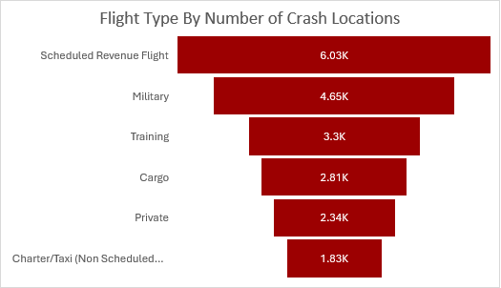

4. **Flight Phase by Crash Impact**

A pie chart shows cruising (66,984) dominates, followed by landing/descent (36,343) and take-off/climb (34,634). This emphasises in-flight and approach risks, with Power BI offering hover-over details.

5. **Aircraft by Number of Survivors**

A donut chart highlights the Douglas C-47 (2,171 survivors) and PZL-MIELEC AN-2 (highest survival rate) with notable survivability, alongside models like Curtiss C-46 Commando (638). Power BI provides clickable segments for comparisons.

6. **Crash Type by Region**

A bar chart shows North America with high human error (3,919) and technical failures (4,718), Asia with technical issues (1,374), and Europe with weather risks (429). This guides region-specific strategies, with Power BI enabling dynamic comparisons.

7. **Global Crash Distribution**

A map visualises crash density, marking North America and Europe as high-risk zones with a focus on the USA and UK. Power BI adds zoom and filter options for detailed geographical analysis.

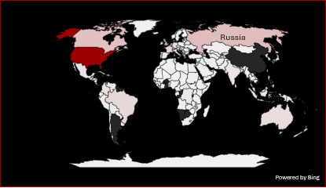

8. **Dashboard**

The Global Airplane Crash Dashboard 2022 integrates these visualisations, offering an interactive platform for stakeholders. Enhanced with Power BI, it allows dynamic exploration of crash trends, causes, and safety risks.

1. Excel Dashboard

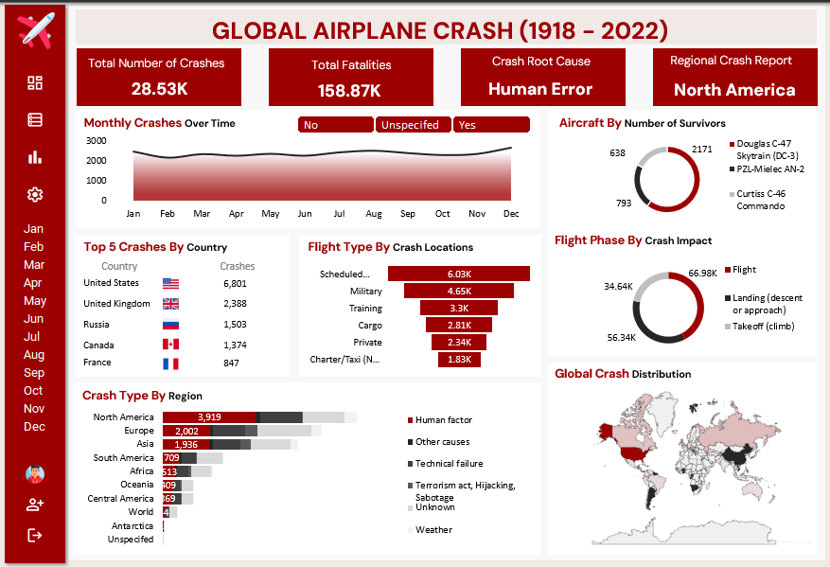

2. Power Bi Dashboards One and Two

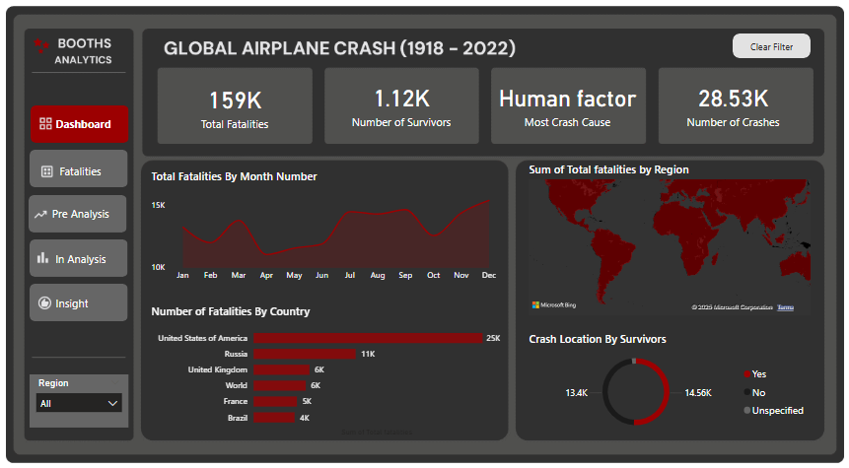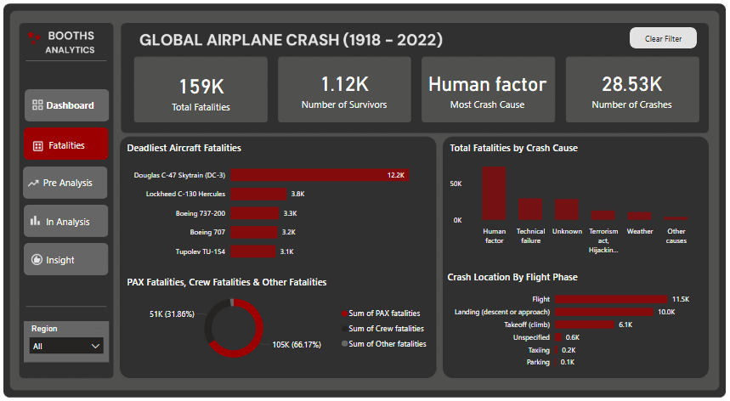

**Explanations**

1. **Seasonal Risks**

The Monthly Crashes Over Time line chart highlights summer peaks, urging targeted safety measures to mitigate weather and traffic-related risks. Power BI’s interactivity aids in identifying specific conditions.

2. **Regional Priorities**

The Top Crashes by Country bar chart identifies the USA, UK, and Russia as priorities for safety interventions. Power BI’s drill-downs support tailored regional strategies.

3. **Flight Type Focus**

The Flight Type by Crash Locations bar chart underscores the need for enhanced safety in scheduled and military flights. Power BI’s filtering enables focused interventions.

4. **Phase Impact Insights**

The Flight Phase by Crash Impact pie chart highlights cruising and landing phases, requiring focused monitoring. Power BI’s details aid in prioritising safety measures.

5. **Design Lessons**

The Aircraft by Number of Survivors pie chart reveals the Douglas C-47 and PZL-MIELEC AN-2’s resilience, offering lessons for future designs. Power BI’s segments support comparative analysis.

6. **Regional Strategies**

The Crash Type by Region bar chart shows varied causes by region, guiding tailored strategies. Power BI’s comparisons help address specific challenges.

7. **Global Overview**

The Global Crash Distribution map provides a geographical overview, highlighting North America and Europe. Power BI’s options enable detailed planning.

# Recommendations and Observations

## Actionable Insights

1. **Human Error Dominance**

Human factors are the leading cause of crashes in North America (3,919), Europe (2,002), and Asia, often due to pilot misjudgments, poor communication, or fatigue during critical phases like take-off and landing (34,634 and 36,343 crashes). Addressing this requires advanced CRM training with scenario-based decision-making and fostering open communication within crews.

2. **Weather-Related Risks**

North America (515 cases) and Europe (429) experience the highest number of weather-related crashes, often during sudden climatic shifts. Improved AI-driven forecasting tools and real-time data sharing can empower pilots to make safer decisions.

3. **High-Risk Aircraft**

The Boeing 737-200 (3,004 passengers + 247 crew) and Douglas C-47 (over 12,000 total fatalities) pose significant risks due to age and design limitations. Modernisation or retirement is urgent, especially in high-traffic regions like the USA (6,601 crashes).

4. **Regional Risks**

Elevated crash rates in the USA (6,601), UK (2,388), and Russia (1,503) reflect dense air traffic and environmental challenges. Tailored safety audits, such as enhancing de-icing in the USA, can address these disparities.

5. **Unscheduled Flights**

Military flights (4,647 crashes) and private flights with lower safety compliance highlight gaps in oversight. Stricter regulations and audits can align safety standards with commercial aviation.

6. **Survivability Insights**

The Douglas C-47 (2,171 survivors) and PZL-MIELEC AN-2 (highest survival rate) demonstrate crash resilience due to robust designs. Studying these features can inform modern aircraft development.

7. **Security Incidents**

Europe’s security-related crashes (429 cases) indicate vulnerabilities. AI cargo screening and hardened cockpits can strengthen security protocols.

8. **Seasonal Patterns**

Summer months show higher crash frequencies, possibly due to weather or travel demand. Pre-season drills focusing on turbulence management can prepare crews effectively.

## Recommendations

1. **Human Error Mitigation**

Expand CRM and fatigue training to reduce human errors (3,919 cases in North America). Annual mental health evaluations will address fatigue risks.

2. **Weather Risk Reduction**

Invest in AI-driven weather prediction tools for the 515 weather-related crashes in North America. Mandate real-time data sharing with flight crews.

3. **High-Risk Aircraft Phase-out**

Audit and accelerate fleet modernisation for the Boeing 737-200 and Douglas C-47, incentivising retirement or retrofitting to reduce fatality tolls.

4. **Regulatory Overhaul for High-Risk Regions**

Enforce stricter oversight in the USA, UK, Russia, and Canada through mandatory safety audits and maintenance protocols for ageing fleets.

4. **Standardized Operational Protocols**

Adopt uniform preventive maintenance checklists and crew assessments globally, with penalties for non-compliance, especially for military flights (4,647 crashes).

5. **Model-Specific Safety Interventions**

Conduct targeted airworthiness reviews for the Boeing 737-200, mandating retrofits or restrictions until safety improves.

6. **Maintenance Systems**

Promote IoT and AI-based maintenance to tackle technical failures (4,718 cases in North America), focusing on older aircraft.

7. **Security Enhancement**

Deploy AI cargo screening and hardened cockpits in Europe to counter security incidents (429 cases).

8. **Seasonal Safety Drills**

Conduct pre-season drills before summer months to mitigate weather-related risks, enhancing crew preparedness.

9. **Operator Audits**

Require operators with recurring incidents to undergo training programs and audits to ensure consistent safety practices.

## Optimisations or Business Decisions

1. **Training Investments**

Allocate budgets for advanced CRM and simulator training for take-off and landing phases (34,634 and 36,343 crashes) to improve pilot performance. Virtual reality can enhance realism, reducing human error.

2. **Technology Adoption**

Invest in AI weather and maintenance systems to address 515 weather-related and 4,718 technical failure cases, providing predictive insights and real-time alerts.

3. **Regulatory Collaboration**

Standardise safety protocols for military flights (4,647 crashes) through international regulator task forces, ensuring global consistency.

4. **Fleet Modernization Incentives**

Incentivise retirement of high-risk aircraft like the Boeing 737-200 and Douglas C-47 with tax breaks, accelerating safety upgrades.

5. **Data Analytics Utilization**

Use real-time crash data analytics to predict risks, such as the 4,718 technical failures in North America, improving maintenance and operational planning.

## Unexpected Outcomes

1. **Survivability of Older Aircraft**

The high survivability of the Douglas C-47 and PZL-MIELEC AN-2 was unexpected, offering design lessons for modern aircraft.

2. **Persistent Human Error**

The dominance of human error (3,919 cases) despite advancements indicates ongoing training gaps, requiring renewed focus.

# Conclusion

## Key Learnings

1. The conclusion highlights that North America and Europe are high-risk regions driven by human error (3,919 cases), technical failures (4,718 cases), and weather-related crashes (515 cases), with the Douglas C-47 and PZL-MIELEC AN-2 offering valuable lessons on aircraft design for improved survivability.

2. Seasonal peaks in summer months and regulatory milestones, such as mandatory flight data recorders, have contributed to a decline in fatal crashes, while the Global Airplane Crash Dashboard 2022 aids stakeholder decision-making with clear insights.

## Success Story of This Data

The dataset has driven safety improvements, enhanced aircraft designs, and rebuilt public confidence in air travel, with future research focusing on real-time data, human factors, aircraft maintenance, AI impact, region-specific factors, and professional interviews to refine safety strategies further.

## Limitations

1. **Historical Data Gaps**

Some records may have missing or inconsistent values, especially for causes or circumstances, limiting insight depth. Older crashes or less-documented regions contribute to these gaps.

2. **Lack of Granular Variables**

The dataset lacks detailed variables like aircraft age, maintenance history, or pilot experience, restricting nuanced analysis.

3. **Regional Reporting Variations**

Differences in reporting standards across regions may affect data comparability, skewing trends and cause distributions.

4. **Subjective Categorization**

The categorisation of crash causes (e.g., human error vs. technical failure) can be subjective, introducing potential inconsistencies.

5. **Limited Technical Depth**

The dataset may lack recent updates or technical variables, such as aircraft age or maintenance history, which could provide deeper insights.

6. **Absence of Firsthand Information**

Firsthand information from airports was unavailable, limiting validation with operational insights.

## Future Research

Future efforts should focus on integrating real-time crash data and maintenance logs for current insights, analyzing pilot experience and fatigue to address human error, and assessing aircraft age and maintenance history for deeper risk understanding. Studying the impact of AI and automation, investigating region-specific factors like air traffic control, and conducting interviews with aviation professionals will further refine safety strategies.

# References

Baaa-acro.com. (1985). Accident Archives | Bureau of Aircraft Accidents Archives. [online] Available at: https://www.baaa-acro.com/index.php/crash-archives [Accessed 22 May 2025].

Harro Ranter (2014). [online] Flightsafety.org. Available at: <https://asn.flightsafety.org/database/>.

www.kaggle.com. (n.d.). Historical Plane Crash Data. [online] Available at: <https://www.kaggle.com/datasets/abeperez/historical-plane-crash-data>.

‌